Structure

Council of Academy
Ramaz Khetsuriani - Honorable -Prezident of Academy
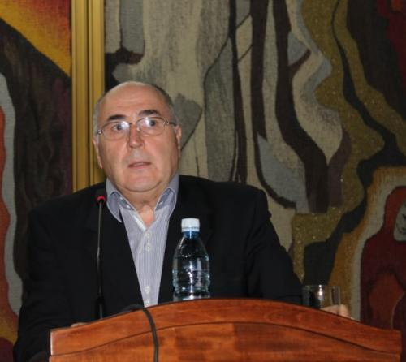
Personal information Date of Birth: May 14, 1949 Place of Birth: Georgia Citizenship: Georgian Education 1956-1966 –31th public school in Kutaisi; Graduated with a Gold Medal 1967-1973 –Tbilisi State Medical University- MD degree; Graduated with an honorary degree 1973-1976 –Tbilisi State Medical University- postgraduate fellow at Anatomy Department Work Experience: 1973-1976 –Tbilisi State Medical University- postgraduate fellow at Department of Normal Anatomy 1978-1985 _Tbilisi State Medical University- Assistant at Department of Normal Anatomy 1985-1990 _Tbilisi State Medical University-Assistant Professor - Department of Normal Anatomy 1990 _ Tbilisi State Medical University - Professor - Department of Normal Anatomy 1996 _ Tbilisi State Medical University-Department Head - Department of Normal Anatomy 1991-1992 _Tbilisi State Medical University- Vice Rector of Internal Medicine and Clinical Practice fields 1992-2005 _Tbilisi State Medical University- Rector 2006_Tbilisi State Medical University-Full Professor – Head of Department of Normal Anatomy Science Degree:Doctor of Medical Sciences, Science Title:Professor Publications:165,in last 10 years -51, 9 manuels,6 monographs,one patent and 3 Supervising doctoral dissertations: Member of Science Academies and Councils: 1. International Academy- Highest School (1995) 2. US International Academy of Science, Industry and Education 1996 3. Albert Schweitzer – Global Medical Academy member 4. National Medical Academy of Poland- member 5. UNESCO- Medical-biological Academy- member 6. President of Academy of Medical Sciences in Georgia Principal Scientific fields and important research: 1. Morphofunctional characteristics of placental vessels in pregnancy and prepartum period a)For the first time, age-related characteristics of placental vessels were linked to mother’s cardiovascular system characteristics. b)Important theoretical concept- regulation of fetal oxygen delivery was described in physiological and morphological terms. B)For the first time it was ascertained that according to fetal heart rate, blood delivery regulation system depends on structural characteristics of the umbilical cord 2. The author and his fellows conducted important anthropologic research and studied acceleration process in Georgian newborns, which has an important impact on working on country’s demographic issue. Participation in International Research: Ways to lengthen life and improve quality of life according to Caucasus traditions and Georgian traditional medicine- ASTC project # 6 895 2003-2007 Chief expert of morphologic research International Congresses and Conferences: 1. A Critical Appraisal of Medical Education. Linkoping, Sweden 29 August 1 September 1999 2. Horizon Scanning in Medical Ed. 2020 vision. Beer sheva, Israel 27-30 August 2000 3. Medical Education and Standards at a Time of Change. Humboldt University, Berlin, Germany, 2-5 September 2001 4. Approaches to better Teaching. University of Lisbon, Portugal 29 August 1 September 2002 5. Relevance in Medical Education. University of Bern, Switzerland 31 August 3 September 2003 6. Linking health promoting programmes with public policies Editing a book, journal or member of editorial committee: 1.Tbilisi State Medical University- Scientific Articles, 1993 2.“UstsoroKarabadini” I part, Tbilisi 1997 3.Georgian Medical News, 1997 4.Georgian Medical News, 1995 Visiting professor in foreign countries, lectures: _ University of Osaka, Japan 1994 _ University of Ankara, Turkey 1995, 1997 _ University of Istanbul, Turkey 1996 _ Medical University of Tokyo, Japan 1996 _ University of Atlanta, USA 1995 _ University of Missouri, USA 1997, 2003 _ Cambridge University 1998 _ University of Paris Descartes, 2000 _ Humboldt University in Paris, 2002 _ University of Toulouse, France 2000 _ University of Reims, France 1998 _ Leuven University, Belgium 2002 Member of professional associations, including international organizations: _ International Association of Universities- member of executive committee _ Association of European Medical Education – cofounder(founded in 1999) _ International Education Association - member _ Global Naturalists’ Association- member of presidium _ Member of Anatomy, Histology and Embryology Association in Georgia _ National Academy of Georgia- expert Awards from government and international bodies: 1. Georgian Honorary Award # 101324 2. National award for textbook “Normal Anatomy”, 1996 3. International Honorary Award 1999 4. Albert Schweitzer Gold Cross 1997 5. Cambridge Honorary Award 19976. Albert Schweitzer Large Gold Medal (title of Commando) 1999 7. World Biography Society- Large Gold Medal for “Honorary Persona”, 2000 8. Cambridge Medal “Among chosen 5000” Honorary Titles: 1. Honorary citizen of Champagne-Ardenne region in France, 2000 2. World Biography Society, co-director from Europe (since1999) 3. Expert at Cambridge and World Biography Society for “Management of Higher Education” In 2021, he was elected as the honorary president of the Georgian Academy of Medical Sciences.

Zurab Kheladze-President of Academy
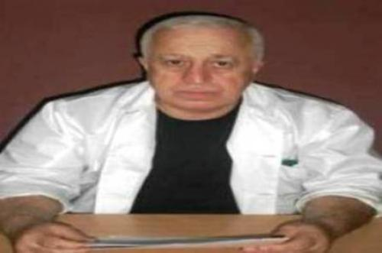
Zurab Kheladze was born in 1952, He graduated Ozurgeti first high school and the Faculty of Medicine of Tbilisi State Medical Institute witch honors. In 1975-1978 he studied in the clinical undergraduate education courses of Anesthesiology-Reanimatology at the same institute.He studied the thesis of the candidates scientific reasersh in 1983 and of the doctoral scientipfic reasersh in 1990 (The protection and protection materials of thesis of the Soviet Unions Supreme Attestation Commission were confidential).He has completed his internship in Moscow (1978, 1980, 1985, 1988, 1989), Kiev (1990, 1891), Rome (1991), New York (1992), Washington (1992), St. Petersburg (1994), Cairo (2005) Tokyo (2014) and other the leading clinics of critical medicine Zurab Kheladzes medical practice involves working as a doctor of the Reanimation and Intensive therapy Department .(1978) and as a head of the Critical Care Medicine Department .(2001) at the N.Kipshidze Republic Central Clinical hospital. At the same time he head of the Reanimatology Service of the V.Bochorishvili Anti-Sepsis Center in 1983.It also led the treatment process of the victims wounded during the Tbilisi,s 9th April tragedy (1989) and military conflicts for territorial integrity of Georgia at the Central Military Hospital (1992). In 1991 he established by the International Center for Disaster Medicine (1991) and after that founded of the Georgian Critical Care Medicine Institute (1994) ,which Director he is present. He was also Member of the Supervisory Board of the O.Gudushauri National Medical Center (2001 ),Chief Specialist (2001) and Expert(2010) in Critical Care Medicine at the Ministry of Labor, Health and Social Affairs of Georgia. Generally since 1975, he has been treated by more than 75,000 patients, including the majority of State and Public Persons, who have been in critical condition at different times. Zurab Kheladzes pedagogical practice includes working as a Assistant (1983), Dotsents(1988),Professor (1994) and Head (1988) of the Chair of Anesthesiology-Reanimatology at the Tbilisi State Medical Institutes. Also, in 2001-2016 he was head of the Chairs of Anesthesiology,Reanimatology and Catastrophe Medicine and Critical Care Medicine Department at the Tbilisi State Medical Institute (University). Also at he was Director of Residency Program (2001), Chairman of Certification Examination Committee (2001) and Head of Continuing Medical Education (2003) in Critical Care Medicine at the Ministry of Labor, Health and Social Affairs. In general, he is raised the absolute majority of doctors working in the Critical Care Medicine Service of Georgia, which is more than 700. Zurab Kheladzes scientific work includes working as scientific worker (1978), senior scientific worker (1988) and head (1988) as a laboratory of Reanimatology at the Tbilisi State Medical Institutes.He was also a member of the Commission of the Reanimatology Problems of the Soviet Union Academy of Medical Sciences (1988) and Coordinator of the Scientific Activities of the Young Reanimtologyst (1988), Chairman of the Dissertation Scientific Board of Anesthesiology&Reanimatology at the Tbilisi State Medical Institute(1994), Chairman of the Dissertation Board of the Institute of Critical Care Medicine of Georgia (from 1994 to present), He is also a Founding Member and Academic Secretary of the Georgian Academy of Medical Sciences (1994) and Vice-President of the same Academy (from 2015 to 2021),Also he was Chair of the Tbilisi Annual Scientific Symposium New Steps in Critical Care&Catastrophe Medicine (from 1991 to present), Editor in Chief of the scientific Journal Critical Care&Catastrophe Medicine (from 2005 to present) and Member of Editorial Board of Georgian Surgery Review (from 2016 to present). In 2017 he was the chairman of the First Workshop of World Interacademy Partnership for Health, Also of his leadership reserved 15 candidate and doctoral dissertation,. He has taken part in about 100 Congress, conferences and other scientific events. He is the author of 801 scientific works,6 monographs,7 manuals and 31 inventions, patents, rational proposals and methodical recommendations, that are certified by internet through 57 individuals daily reading in 156 countries worldwide. Zurab Kheladzes expert activities include working as an invited member of the Legislative Commission of Health Care of Parliament of Georgia (1996). He was also the chairperson of the State Medical Standards Commission in Anesthesiology and Critical Care Medicine (1996) .He is a member of the National Commission for Bioethics (1997).He is also prepared by the Georgian President decree N100 ( 2001) On criteria for the human brain death .It has been conducted at different times of the treatment process expertise of the patients in critical condition of Georgian and other countries. Zurab Kheladzes professional organizations include the establishment of Georgian Association and Catastrophe& Critical Care Medicine ,which President its from 1992 to present. He is also a Member of the World Federation of Intensive&Critical Care Medicine Associations Member of the European Society of Intensive Care Medicine and Founder Member of The World Global Sepsis Alliance. It was also the Regional Head of the International Projects ICON (2015) and EPIC-3 (2017), Also under the auspices of the European Union Intensive Care Medicine Society Project Pneumonia Inspire Regional Supervisor (2016) .He is considered to be one of the founders of the Critical Medicine Service In 2021, he was elected as the president of the Georgian Academy of Medical Sciences.

