### Departament of Chirurgical Medicine

**Alecsander Tsalugelashvili - Head of Department**.

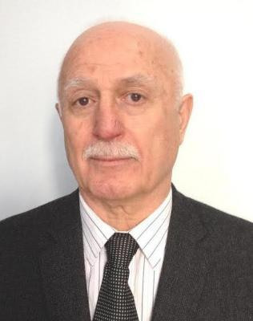

Born in 1945 On September 14 Zaridzeebi in Tianeti district. After graduating from the Military Task Force in the Tusheti region of Tianeti district, he graduated from the medical institute of Khabarovsky in the medical faculty of 1971. Medical activities started in Tbilisi In the General Surgical Department of Wiesichem, the post of the Division, after a certain period, was performed by the department. Duty of the Gamgebeli. 1973 Worked at He is still a doctor in the bureau in multi-profile hospital, and then chief specialist. 1979 He worked in Georgia. Oncology Center at the Torroko-Abdominal Clinic as Ordinator, and later in the position Until 1994, the Torrell Clinic was guided by a research team studying cancer of the esophagus and gastric prostate part 1994. From the second half he led the gastroenterologist. The clinic, one year later, headed a newly established Abdominal Clinic, where he conducted 350-400 surgeries each year. 2013 In the course of six years, she performed 13,000 more surgeries (general surgery, tissue pathology, chest pathology, gynecologic, urological, traumatological, soft tissue and bone in the six years of her life) Tumor, mammalian pathologist H or more). A mental therapy was introduced with the help of "Hepek" method, as well as intraoperative radiation therapy. A large work is undertaken for the premature disease of the disease, during which medical personnel are traveling on the prophylactic examination, often participating in television programs and involved in more than 250 scientific studies, including 6 monographs. The last monologue "Emergency Surgery for Oral Cortex Cancer Diseases" was published in 2015. At this stage he continues to work in the university clinic, the chair of the New Academic Board of New Vision University, as well as the Chairman of the Dissertation Scientific Board. In 1983 he defended candidate dissertation and in 1994 doctoral dissertation. In 1998 he became a laureate of state prize in onco-plastic surgery. In 2000 he became the Knight of the Order of Honor. In 2016 he became an academician of the Scientific Academy of Medicine. Is an honorary citizen of Tianeti. His direction is preserved in 8 thesis,.

**Nicholas Kintraia**

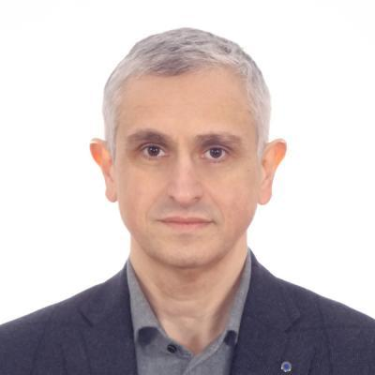

Title; Professor. Academician of Georgian Medical Scientific Academy Date of Birth: May 10. 1969 Place of birth: Tbilisi; Georgia Education: 1987-93 Student of the Tbilisi State Medical University 1993-95 Passed postgraduate course. Passed State exam and got OB/GYN Qualification. Diploma No.128 1996 Defended the Ph.D. thesis 1997 Passed one month training in “Clinicum Gross Hadern” Munich Bavaria 1998 Passed 10 month training in Anatomy, Gynecology and Urogynecology , at Louisina State University Medical School 1999 Passed 3 month training in IVF at Dokkyo University Medical Senter, Japan. 2000 Became a Doctor of Medical Science. 2003 Granted a Professors Title 2010 Passed exam for European University Diploma of Gynecological Operative Endoscopy. (France. Clermont-Ferand.) 2017 Granted an Academician Title of Georgian Medical Scientific Academy MEDICAL SOCIETY AFFILIATION President of Georgian Obstetricians and Gynecologists Association Member of Europian Society for Gynecological Endoscopy The interest area: OB/GYN, Perinatology, Gynecological Operations,Laparascopy. Present occupation: Tbilisi State Medical University, Head of OB/GYN Department Full time Professor. Head of Gynecologcal Department at the Chachava clinic. OB/GYN Residency Programe Director. Emory University Clerkship Program Director at TSMU Language:Georgian, English. Russian

**Zviad Kheladze**

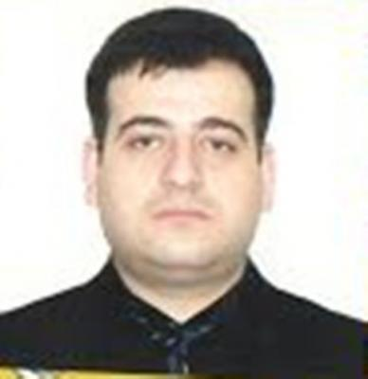

Date and Place of Birth: 1085,16 junay,Georgia, .Tbilisi Education: 2005-Georgian Institute of Critical Care Medicine.Academic Degree of Diploma Specialist 2006 -2006-InternationalHausSertificate 2008 - Academic Degree of Doctor of Philosophy in Medicine. 2009 - Critical Medicines in Certified Doctor 2012 - 2012წ–„Sabit Hospital Administration Program”(Unaited States Department of Americe) Job status: 2005-2006 - Nurse of Critical Care Medicine Department of the Central University Clinic 2006 – 2006-Specialist of the Foreign Relations Department of the Central University Clinic 2006წ-2008-Head of Foreign Relations Department of the Georgian Institute of Critical Care Medicine 2008-2009- Head of the "Critical Care Medicine" Program. in the Georgian Critical Care Medicine Institute 2010 - present - Deputy Director of the Georgian Institute of Critical Care Medicine. Clinical Activities: From 2010 till now- he directs the clinical work of the Georgian Institute of Critical Care Medicine, conducts daily creep and directly curates the treatment of patients with critical condition. 2009 -2014 -Tbilisi State Medical University- Member of the residency program in “Critical Care Medicine” 2014-2016- Georgian Institute of Critical Care Medicine.-Member of residensy program“Critical Care Medici Georgian Institute of Critical Care Medicine- The head of the residency program "AnestesioIologyst& Reanimatology, " Pedagogical Activities: 2006-2008 - Assistant Professor of The Georgian Critical Care Medicine Institute- Head of the Patients Care Program. 2008 -2009 - Associate Professor of Critical Care Medicine Institute- Head of "Critical Care Medicine" Program. 2009-present -Full Professor of Critical Care Medicine Institute- Head of "Critical Care Medicine" Program. 2009-2015 - Tbilisi State Medical University- invited teacher at English language faculty. Scientific activities: From 2005 till now - 597 scientific writers including 5 manuals (three in English), 3 monographs and 4 patents. 2015-present- Member of the editorial board of magazine "Critical Care&cGatastrophe Medicine”" 2016 - till now - General Secretary of The Tbilisi Annual International Scientific Symposium "News Steps in Criticasl Care&Catastrophe Medicine” 2017 – First International Workshop of the Worlds InteracademyPartnershyp- General Secretary of the 2007 –Editor Z.Kheladze - "Critical Medicine" Guide for Doctors and Students, Tbilisi-715 pp. Public Activities: 2010 - present - Vice-President of Georgian Association of “Catastrophe&Critical Care Medicine Knowledge of computer programs: Windows,Microsoft Office,Adobe Dreamweaver (perfectly) Knowledge of foreigners: English (fluent), Russian (freely)

**Shota Jafaridze**

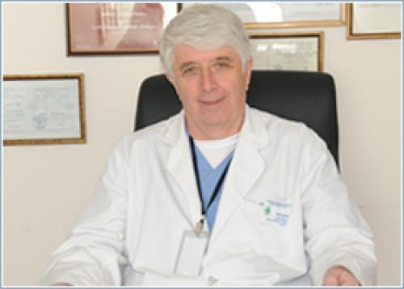

Date of birth: 20.10.46. Marital status: Educatiom: 1953-1963 Oni Kvashkheti secondary school graduated from the silver medal. 1963-1969 Faculty of Medicine of Tbilisi State Medical Institute; 1969-1970 Courses of General Surgery and Oortinolaryngology; 1975-1979 Postgraduate Student of the Doctor of the Doctors Training Center in Tbilisi In 1979, the Moscow-ear-nose and throat diseases, the Institute of the thesis: Реабилитация больных хроническим гнойным средним отитом с тяжолим нарушениями слуховой функций при помощи имплантируемых акустических устроиств (колумелизирующих и экранирующих протезов). Accepted scientific degree of candidate for medicine sciences; 1993. Doctoral thesis in the Institute of Mental Medicine of Moscow in 1993 to preserve Doctoral thesis on the subject: The scientific degree of Doctorate of Medicine of Medicine was awarded to the Medical Doctor of Medicine. 1987-1988 Internship in Hungary 10 months; Budapest Institute of Doctors Training, Outerinolaryngology Clinic 1992 Internship in the United States 3 months; Chicago Oortinolaryngology Clinic Austria-Germany Internship 3 months. Oortinolaryngological clinics of the University of Stubourg and Dresden Scientific degree and rank: 1979 awarded scientific degree of candidate for medicine sciences; 1993 Scientific degree of Doctor of Medicine of Medicine was awarded. 1993-1999 Professor of the TSU Nurse-Nose Chair; Since 1999, she has been a full professor of the TSU Work experience: 1970-1987 Physician Oortinolaryngologist of Bolnisi Regional Hospital 1987-1993 Head of Nerve Department of Marneuli Narcotics Hospital; 1993-1999 Professor of the TSU Nurse-Nose Chair; Since 1999, she has been a full professor of the TSU Kel-Nurse Department. Since 2010, the National Center for Diseases Lor-nose-Japaridze KEVANISHVILI clinic director Since 1993 the Ministry of Health of the Ministry of Health of the otolaryngologist Since 2000, expert Otolaryngology Scientific publications: He is the author of 57 scientific works, 4 inventions and 1 monograph. He has been guided by seven Candidates and one Doctoral thesis In the 70s of the last century, when the ear reconstructive surgery level in some pathologies did not solve the problem of hearing loss, he created a mechanical propagation mechanism through a round-screen screening. He has introduced a number of innovations in Georgia such as mechanical propagation of the hearing body, endoscopic surgery of the nose and its supplemental fibers, less invasive stapidotomy method in Otosclerosis, modern methods of mid-ear reconstructive surgery. It is noteworthy that in 1999 the first instance of the Kolkhar implantation was introduced in the Caucasus in full deafness and morbidity. The method of safe approach to the type of nerve without the use of the face nerve monitor during this operation was developed. He participated in various types of forums in many international symposiums and congresses, Pedagogical activity: 1993-1999 Professor of the TSU Nurse-Nose Chair; From 1999 to present, the Head of the Department of Full Professor of the Department of Diseases of the TSU Since 1999, the director and program director of the resident program in Oortinolaryngology .He is the author and program director of the residency program in otinolaryngology. Participation in scientific-grant projects: participated in the grant project of the Ministry of Health of Georgia "Endoscopic Diagnostics and Surgical Treatment of Loss Nose and Nose 1997" Professional and Scientific Organizations Membership: Vice President of Georgian Association of Oortinolaryngology; Academician of the Academy of Medicine of Georgia; American member of American otinolaryngology and academy of head and neck surgery; Regional Secretary of the European Otolagos and Otonovorologists Academy; In 2013 he was elected as an Academician of the National Academy of Sciences of Georgia

**Zurab Kheladze**

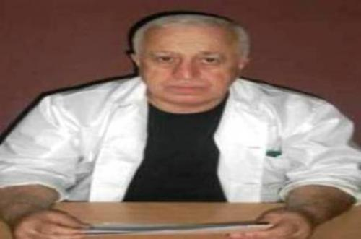

Zurab Kheladze was born in 1952, He graduated Ozurgeti first high school and the Faculty of Medicine of Tbilisi State Medical Institute witch honors. In 1975-1978 he studied in the clinical undergraduate education courses of Anesthesiology-Reanimatology at the same institute.He studied the thesis of the candidates scientific reasersh in 1983 and of the doctoral scientipfic reasersh in 1990 (The protection and protection materials of thesis of the Soviet Unions Supreme Attestation Commission were confidential).He has completed his internship in Moscow (1978, 1980, 1985, 1988, 1989), Kiev (1990, 1891), Rome (1991), New York (1992), Washington (1992), St. Petersburg (1994), Cairo (2005) Tokyo (2014) and other the leading clinics of critical medicine Zurab Kheladzes medical practice involves working as a doctor of the Reanimation and Intensive therapy Department .(1978) and as a head of the Critical Care Medicine Department .(2001) at the N.Kipshidze Republic Central Clinical hospital. At the same time he head of the Reanimatology Service of the V.Bochorishvili Anti-Sepsis Center in 1983.It also led the treatment process of the victims wounded during the Tbilisi,s 9th April tragedy (1989) and military conflicts for territorial integrity of Georgia at the Central Military Hospital (1992). In 1991 he established by the International Center for Disaster Medicine (1991) and after that founded of the Georgian Critical Care Medicine Institute (1994) ,which Director he is present. He was also Member of the Supervisory Board of the O.Gudushauri National Medical Center (2001 ),Chief Specialist (2001) and Expert(2010) in Critical Care Medicine at the Ministry of Labor, Health and Social Affairs of Georgia. Generally since 1975, he has been treated by more than 75,000 patients, including the majority of State and Public Persons, who have been in critical condition at different times. Zurab Kheladzes pedagogical practice includes working as a Assistant (1983), Dotsents(1988),Professor (1994) and Head (1988) of the Chair of Anesthesiology-Reanimatology at the Tbilisi State Medical Institutes. Also, in 2001-2016 he was head of the Chairs of Anesthesiology,Reanimatology and Catastrophe Medicine and Critical Care Medicine Department at the Tbilisi State Medical Institute (University). Also at he was Director of Residency Program (2001), Chairman of Certification Examination Committee (2001) and Head of Continuing Medical Education (2003) in Critical Care Medicine at the Ministry of Labor, Health and Social Affairs. In general, he is raised the absolute majority of doctors working in the Critical Care Medicine Service of Georgia, which is more than 700. Zurab Kheladzes scientific work includes working as scientific worker (1978), senior scientific worker (1988) and head (1988) as a laboratory of Reanimatology at the Tbilisi State Medical Institutes.He was also a member of the Commission of the Reanimatology Problems of the Soviet Union Academy of Medical Sciences (1988) and Coordinator of the Scientific Activities of the Young Reanimtologyst (1988), Chairman of the Dissertation Scientific Board of Anesthesiology&Reanimatology at the Tbilisi State Medical Institute(1994), Chairman of the Dissertation Board of the Institute of Critical Care Medicine of Georgia (from 1994 to present), He is also a Founding Member and Academic Secretary of the Georgian Academy of Medical Sciences (1994) and Vice-President of the same Academy (from 2015 to present),Also he was Chair of the Tbilisi Annual Scientific Symposium New Steps in Critical Care&Catastrophe Medicine (from 1991 to present), Editor in Chief of the scientific Journal Critical Care&Catastrophe Medicine (from 2005 to present) and Member of Editorial Board of Georgian Surgery Review (from 2016 to present). In 2017 he was the chairman of the First Workshop of World Interacademy Partnership for Health, Also of his leadership reserved 15 candidate and doctoral dissertation,. He has taken part in about 100 Congress, conferences and other scientific events. He is the author of 801 scientific works,6 monographs,7 manuals and 31 inventions, patents, rational proposals and methodical recommendations, that are certified by internet through 57 individuals daily reading in 156 countries worldwide. Zurab Kheladzes expert activities include working as an invited member of the Legislative Commission of Health Care of Parliament of Georgia (1996). He was also the chairperson of the State Medical Standards Commission in Anesthesiology and Critical Care Medicine (1996) .He is a member of the National Commission for Bioethics (1997).He is also prepared by the Georgian President decree N100 ( 2001) On criteria for the human brain death .It has been conducted at different times of the treatment process expertise of the patients in critical condition of Georgian and other countries. Zurab Kheladzes professional organizations include the establishment of Georgian Association and Catastrophe& Critical Care Medicine ,which President its from 1992 to present. He is also a Member of the World Federation of Intensive&Critical Care Medicine Associations Member of the European Society of Intensive Care Medicine and Founder Member of The World Global Sepsis Alliance. It was also the Regional Head of the International Projects ICON (2015) and EPIC-3 (2017), Also under the auspices of the European Union Intensive Care Medicine Society Project Pneumonia Inspire Regional Supervisor (2016) .He is considered to be one of the founders of the Critical Medicine Service. In 2021, he was elected as the president of the Georgian Academy of Medical Sciences.

**Gia Tomadze**

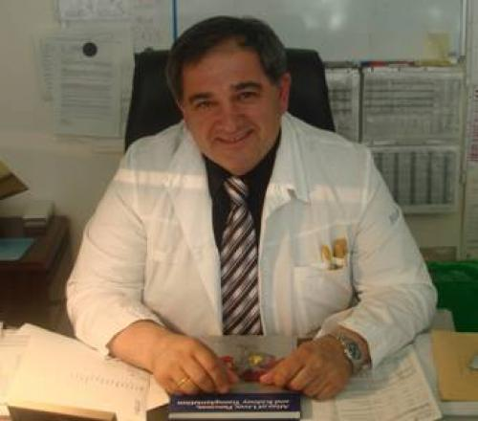

Gia Tomadze, M.D., Ph.D., Sc.D., FICS Professor of General Surgery, Head, Surgery Department N2, Tbilisi Sate Medical University President, Georgian Surgical Association Born in 1955, in Georgia. Graduated from Internal Medicine department of Tbilisi State Medical Institute in 1978. Graduated clinical internship and fellowship in General Surgery in Moscow Scientific–Research Center of Surgery in 1979-1984. Defended Ph.D. dissertation in 1982 (Occlusion of pancreatic ducts with silicone). Fellowship in the Department of Surgery of the University of Minnesota (Minneapolis) in 1988-89. Topic of research: Combine pancreas-kidney transplantation in the treatment of complicated diabetes (thesis on Sc.D defended in Tbilisi State Medical University (TSMU) in 1993). Academic staff of Tbilisi State Medical University since 1984: Assistant professor, Associated Professor and Full Professor of TSMU surgery department. Short term trainings in organ transplantation: USA (1988-89), Turkey (2010), Swiss (2007). Participated in more than 60 National and International professional meetings. Author of more than 150 publication. Peer review member of “TRANSPLANTATION”, “Journal of WORLD SOCIETY OF EMERGENCY SURGEONS”, “MEDICINE”. Founding President of Georgian Association of Transplantologists (1997), Member of expert Committee of CoE in organ and tissue transplantation since 2000, Head of Transplantation Commission of National Academy of Sciences of Georgia, member of Internation College of Surgeons, member of World Society of Emergency Surgeons. National representative of European Transplant Association’s Journal „Organs, Tissues & Cells“. State certificates in general surgery, Public Health, Organ Transplantation, Endoscopic surgery, Surgical oncology, Endocrine surgery. Good Clinical Practice certificates issued by London School of Medicine (2011, 2008). Currently head of Surgery Department N2 of Tbilisi State Medical University, Clinical Director of Emergency Surgery and Traumatology Center at Tbilisi City Hospital #1, Head of Transplantation department in High Technology Medical Center – University Clinic, President, Georgian Surgical Association.

**Nodar Lomidze**

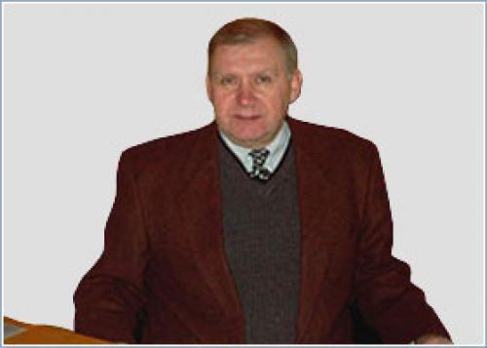

He was born in 29 February, 1948 in Kutaisi, Georgia Education: 1955-1966 High school, certificate with honor. Tbilisi, Georgia 1966-1972 Tbilisi State Medical University, diploma with honor # 000777 1972-1977 Postgraduate courses at Tbilisi State Medical University 1979-1979 Postgraduate course in Surgery, Medical Academy, Tbilisi, Georgia 1983-1983 Postgraduate course in Surgery, # 1 Medical Institute, Moscow, Russia 1989-1992 Doctoral course at Tbilisi State Medical University, # 2 Medical Institute, Moscow, Russia. Medical Licensure: 1978- Candidate of Medical Sciences, #005929 1952- Doctor of Medical Sciences, #016327 1994- Associate Professor of Medicine, #000020 1995- Professor of Medicine, #000062 Certificates: Certificate in General Surgery, #5557 Certificate in Proctology, #27550 Certificate in Oncology, #008985 Certificate in Public Health and Management, #035293 Certificate in Thoracic Surgery, #000590 Certificate in Endocrine Surgery, #000591 Certificate in Plastic and Reconstructive Surgery, #005170 Professional Experience: 1975-1978 Researcher, Institute of Experimental Morphology, Tbilisi, Georgia. 1979-1979 Surgeon, #1 Outpatient’s Clinic 1979-1980 Surgeon, Republic Central Clinical Hospital, Tbilisi, Georgia 1980-1989 Assistant Professor at the Department of Surgery, Tbilisi State Medical University 1992-1993 Associate Professor at the Department of Surgery, Tbilisi State Medical University 1992-1994 Vice-dean of the faculty of General Medicine, Tbilisi State Medical University 1993-1995 Professor of the Department of Surgery, Tbilisi State Medical University 1994-1998 Vice-Rector, Tbilisi State Medical University 1995 till present: Head of the Department of Surgery, Tbilisi State Medical University 1998 -2008 The President of Association of Surgeons of Georgia 1999 till present: Member of the Dissertation Council, Tbilisi State Medical University 2002 till present: Member of Georgian Academy of Medical Sciences 2006 till present Head of Certification Examinations in Surgery in Georgia 2007 till present: Member of the National Council of Bioethics 2007 till present Program Director of Residency in “General Surgery”. 2008 till present Vice President of Association of Surgeons of Georgia 2010 till present: Member of professional Development Board of Ministry of Labour Health and Social Affairs of Georgia 2015 till present: The First University Clinik of Tbilisi State Medical university. Head of the Department of Surgery. Scientific Activities: Scientific articles: 162Books: 2Invention: 2Method recommendations: 3,Head of candidate dissertation -1, Adviser of doctoral dissertation – 2.He has taken part in the work of more than 50 scientific congreces,conferences and other scientific activities 2007 till present: _ journal “Exsperimental & Clinical Medicine“. Tbilisi.Member of Scientific Editorial Board. 2016 till present: Georgia-US joint scientific journal “Gergian Medical News”. Tbilisi-New York. Member of Scientific Editorial Board. 2016 till present: “Georgian Surgery biulletin”. Tbilisi, Member of Scientific Editorial Board. Membership: 1995 till present: The G. Mukhadze Soiciety of Surgeons 1996 till present: International Association of Parenteral and Enteral Nutrition. 1998 till present: Association of Surgeons of Georgia 1998 till present: Association of Georgian Transplantologists. Computer: Windows 98, 2000, XP, Word, Power point, Internet. Languages: Georgian, Russian, English

**Rema Gvamichava**

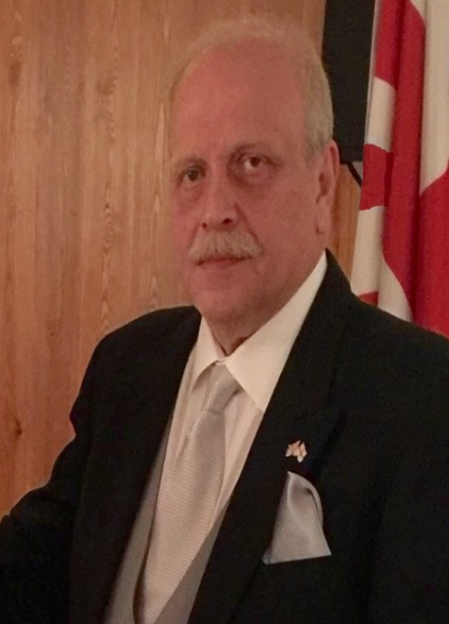

Date of birth: 18 June 1961. In 1978 he graduated with honors from Tbilisi 30th Secondary School. In 1979-1985 he graduated with honors from the Medical Faculty of the Tbilisi State Medical Institute. At the same time in 1981-1984 he graduated from Tbilisi State University. Evening Department of the Faculty of International Relations, University. In 1985 he was appointed Resident Doctor of the National Oncology Center, which was founded by his grandfather Professor A. Gvamichava and bears his name. In the same year he was sent on a business trip to St. In the Department of Colorectal Surgery of the Union Center for Oncology in Moscow. In 1989, St. He successfully defended his dissertation on the topic: "Comparative analysis of compression and hand-formed anastomoses during surgical treatment of Colling cancer" in Moscow. Gvamichava National Oncology Center for the position of Senior Researcher. 1994 Elected after Tbilisi. Assistant Professor, Department of Oncology, Medical University. In 1998, the U.S. Finished an 8-month internship in the USA with the funding of the College of Surgeons. 3 Clinics / Mount Sinai Hospital (New York), Cleveland Clinic (Cleveland), Fort Lauderdale (Florida). In 2000, he founded the Cancer Prevention Center, which he heads to this day. 2000 Elected after Tbilisi. Associate Professor of the Department of Oncology, Medical University. 2007 Elected after Tbilisi. Associate Professor, Department of Oncology, Medical University. Since 2015 he has been elected Tbilisi. Head of the Oncology Department of the Medical University and Full Professor. 2008-2017 Worked as the director of the National Screening Center from 2017 to 2020. Director of the "Universal Medical Center" (former A. Ghvamichava National Oncology Center) 2020 - is still the director of the Center for Radiation and Nuclear Therapy and has published 132 scientific papers. 3 monographs including Oncology Handbook, which won the Georgian National Prize in 2011. Awarded the Order of Merit. Since 2005 he has been the founder and head of the Georgian Society of Clinical Oncology. He is also the publisher and editor-in-chief of the journal Clinical Oncology.

**Ilia Chanukvadze**

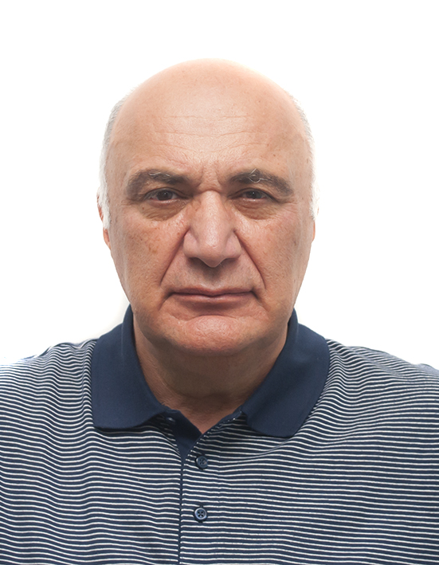

Was born in the city of Makharadze (today's Ozurgeti) in 1949. Here, in 1966, he graduated from his home school with a gold medal. In the same year, he enrolled in the Tbilisi State Medical Institute at the Faculty of Medicine, which he graduated in 1972 with honors, "Red Diploma". Professional activity He completed his internship in Rustavi, in the city hospital, where he was already performing small-scale emergency and planned operations, and was engaged in scientific activities at the same time. For the next 3 years, he worked as a traumatologist on night duty at Klak Rustavi Polyclinic. In 1975, he enrolled in postgraduate studies at the Tbilisi State Medical Institute at the Department of Operative Surgery and Topographic Anatomy. 1979 from the protection of the qualification theme. Until 1982, he worked as an assistant of the same department. From 1982, he moved to the Department of General Surgery of the Faculty of Medicine as an assistant. Since 1990, he has been elected as a docent of the Department of General Surgery. Since 2002, he has been an assistant professor of the department. Since 2013, he has been an associate professor and head of the Department of Surgical Propedeutics. Since 2015, he has been a professor and head of the Department of General Surgery, and since 2023 he has been awarded the title of Emeritus. Under the guidance of professor Givi Gonjilashvili, he mastered operations on abdominal organs. Performed planned and urgent operations. As the head of the surgical team, he performed more than 500 emergency surgical interventions. For the first time in Georgia in 1984, he performed breast lymphatic drainage and sorption for the purpose of extracorporeal detoxification, which was successfully implemented in the clinic. Also, the blockade of the liver gate and pancreatico-duodenal zone provided by Professor Feodorov was implemented in the clinic using round yoga. Since 2014, he is the head of the surgical service of critical medicine in the clinic of Academician Zurab Kheladze. Scientific work He chose the liver as a scientific test. In particular, the surgical anatomy of the portal complex of this organ and its soft skeleton, in the study of which he is considered a pioneer and the author of the direction, The results of Chanukvadze's scientific research are reflected in more than one hundred published works, two inventions and 4 rational propositions. Publications in Berlin, Romania, London, Milan, Rome, Czech and Russian editions. In 2016, a monograph was published in the United States of America - BILE DUCT, Functional Anatomy, Disease and Injury Classification and Surgical Management 2016. New York p1-87. He is a member of the editorial board of Georgian and European scientific journals. The fundamental studies he conducted, in particular, the structure of the soft skeleton of the liver, i.e., the structure of the fibrous matrix of the portal channels and hepatic veins, became the basis for the emergence of a new direction in hepatology, which was reflected in doctoral studies: Leila Patarashvili - "Peculiarities of the structure of the liver matrix" 2021. Ketevan Jandieri - "Biliary vascularity of the portal complex" Elements in the conditions of mechanical cholestasis 2021". Revaz Otarashvili - "Influence of bile ducts on liver veins, in conditions of mechanical cholestasis and cholangitis." Pedagogical activity He has been engaged in teaching since 1974. For 49 years, he taught and continues to teach thousands of students in general surgery, topographical anatomy and operative surgery. He systematically selected and worked with students distinguished by hard work and talent, taking them on the path of science. He is the author of 3 educational methodical recommendations. Co-author of the "General Surgery" textbook in 2008. Editor of Professor Archvadze's "General Surgery" textbook. With his initiative and efforts, for the first time in the history of medical education in Georgia, a university clinic was established on the street named after Dimitri Uznadze. On his own initiative and with the support of the government, in the eighties, hundreds of students from the 3rd and 4th years underwent medical practice in the leading clinics of Moscow and Leningrad, where the level of professional education was significantly increased.

**Guram Akhaladze**

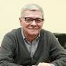

Born in Tbilisi in 1952, he graduated from the Tbilisi State Medical Institute with the highest grades in 1975. For the next two years, he worked as a doctor-surgeon in the district hospital. In 1978-1983, he completed his clinical residency. Petrovsky st. In the department of surgery for liver diseases in the surgery center. For the period, the surgery center represented a large school of surgery, where it was possible to listen to lectures and attend operations of prominent surgeons, such as: B.V. Petrovsky, E.N. Vantsian, N.N. Malinovsky, M.D. Knyazev, M.I. Perelman, M.D. Patsiora, A.F. Chernousov, O.B. Milonov. Under the guidance of a brilliant surgeon and a real Russian intellectual, Professor A. Smirnov, Guram Germanesdze completed and defended his candidate's thesis in 1984 on the topic: "Satisfactory choledochoduodenoanastomosis" The causes of long-term results and repeated operations at the same time". In 1984, he returned to Tbilisi and worked as an assistant in the department of surgery of Tbilisi State Medical Institute No. 2, under the guidance of Professor G. Tatishvili. He performed many surgeries and was passionate about scientific and pedagogical work. In the 1990s, during his time as a civilian in Georgia, he simultaneously served as the chief surgeon of the War Veterans Hospital. In 1986-1988, he completed his doctorate at Ray. M. Sechenov's office. in the Department of Liver and Metabolic Surgery of the First Moscow Medical Institute, where in 1994 he defended his doctoral dissertation under the guidance of Professor I. Galperin on the topic: "Suppurative cholangitis: issues of pathogenesis, clinical forms, treatment differentiated according to the severity of the course". face From 2007 to 2012, he was the head of the Department of Liver Surgery of the Moscow Medical Academy, and then the chief scientist-collaborator, and from 2007 to 2012 he held the position of the professor of the Department of Surgery at the Faculty of Post-Diploma Professional Education of Sechenov University. The fundamental issues of the functional reserve of the liver in the pathogenesis of psychosis. One of the first to develop the technique of minimally invasive interventions during acute cholecystitis, cholangitis, liver abscesses and cysts, acute and chronic pancreatitis, pancreatic cysts, liver and pancreas tumors. He was one of the first to work on the issues of chronic pancreatitis surgery and laparoscopic surgery of liver and pancreas tumors. Since 2012, he has been a scientific-researcher of surgery and surgical technologies in oncology of the Russian Federal State Budgetary Institution, "Russian Scientific Center of X-ray Radiology". Former chief scientist-collaborator. Guramakhaladze's many years of practical and scientific activity is connected with hepatopancreatobiliary surgery and he shares his experience with numerous students who are numerous around him, both in Russia and Georgia. He is the author of 220 overprint works, as well as 6 textbooks, has 3 authorship certificates for many years, is a member of the editorial board of the Journal of Surgical Hepatology, an honorary member of the Association of Hepatopancreatobiliary Surgeons of the CIS countries, an honorary member of the Pancreatic Club of Belarus. For several years, he was a member of the editorial board of the journal "Hepato-Gastroenterologist".

**Reuven Nelliger (Ruben Eligulashvili)**

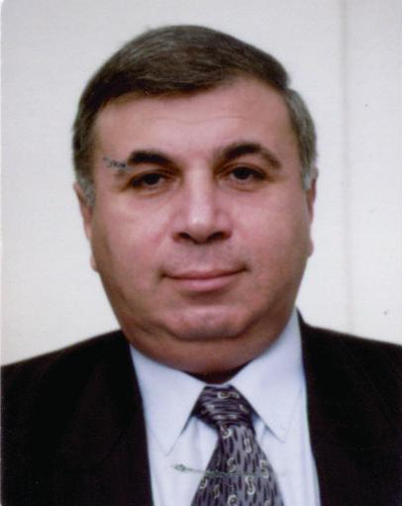

He was born on November 14, 1951 in Tbilisi. In 1968, he graduated from the 44th Public School of Tbilisi. In 1968 - 1974, he was a student of the Faculty of Medicine of the Azerbaijan State Medical Institute. 1978 - 1982, he was a graduate student in surgery at the Moscow Institute of Transplantology and Artificial Organs. 1987 - he received his medical degree at the Moscow All-Union Institute of Transplantology and Artificial Organs. Degree of candidate of sciences. In 1997-2023, he completed general and cardio-resuscitation compulsory training course, and in 2006 he studied laparoscopy course in Geneva. In 1974-1975, he was an intern at the surgical department of the Tbilisi Emergency Clinical Hospital. In 1975-1976, he worked as a teacher of the military-medical course of the Tbilisi Technical University. In 1979-1981, he performed the duties of a doctor at the surgical department of the 67th Clinical Hospital in Moscow. 1981-1985 - Chief surgeon of Lanchkhuti district, head of the surgical department. In 1985-1995 he was - head of the surgical department of the Central Republican Hospital of Georgia. In 1968-1995, he was a resident of the surgical department of Wolfson University Medical Center of Tel Aviv University. In 1998, he worked as a senior surgeon at Asuta Medical Center. In 1998, he received the certificate of an Israeli health doctor - in the specialty of general surgeon. In 1999, he was the head of the surgical clinic of the "Leumit" medical service. In 1998 - 2000, he worked as a senior physician of the surgical department of the Wolfson University Medical Center of Tel Aviv University. 1999 This year, he performed the duties of the senior surgeon of the Israel Medical Association - "Clalitis". In addition, since 2000 - he worked as the head of the surgical clinic of the "Maccabi" medical service. From 2009 to the present, he is the founder and medical consultant of the joint Georgian-Israeli clinic "Gidmedi". Since 2000, he has been working as a senior surgeon at the Kaplan University Medical Center of Jerusalem University, and since 2000 he has been giving lectures to students of the Faculty of Surgery of Jerusalem University, his professional and scientific research interest is: general surgery; Liver and biliary tract surgery; laparoscopic surgery; Oncosurgery; breast surgery; proctology; Trauma and emergency surgery. He is the author of more than 50 scientific works. He has participated in the work of many international scientific congresses, conferences and symposiums.